Annex D: Results production in absolute values
All results are presented per kWh.
Modules
Results for the production (material input) of 1 kWh by a multi Si module using Ecoreport tool
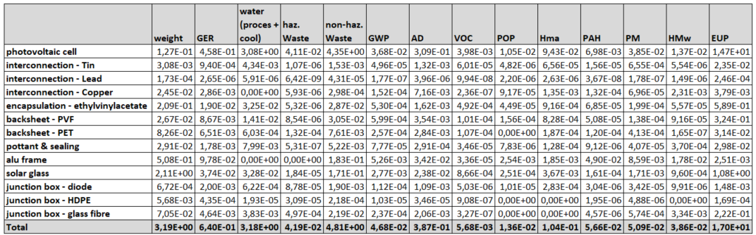

Inverters

Results for production (material input) of 1 kWh by a 2500 W inverter using EcoReport tool
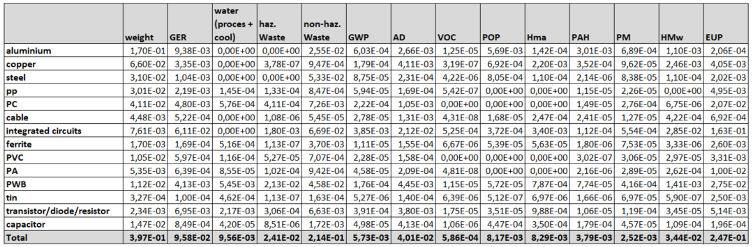

Results for production (material input) 20 kW inverter using EcoReport tool
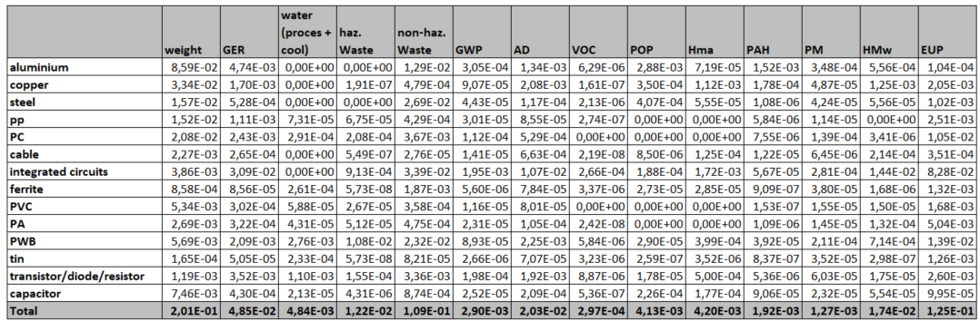

Results for production (material input) 1500 kW central inverter using EcoReport tool
